**DAILY ONLINE ACTIVITIES SUMMARY**

|  |  |  |  |  |  |  |  |
| --- | --- | --- | --- | --- | --- | --- | --- |
| **Date:** | **22/05/2020** | | | | **Name:** | **AMBIKA V** | |
| **Sem & Sec** | **4th SEM 'A' Section** | | | | **USN:** | **4AL18CS005** | |
| **Online Test Summary** | | | | | | | |
| **Subject** | | **Operating system** | | | | | |
| **Max. Marks** | | **30** | | **Score** | | **17** | |
| **Certification Course Summary** | | | | | | | |
| **Course** | **CLOUD FOUNDATION** | | | | | | |
| **Certificate Provider** | | | **greatlearning academy** | **Duration** | | | **3.5 hours** |
| **Coding Challenges** | | | | | | | |
| **Problem statement** 1:Write a C or Java program to implement round robin type of process scheduling.  **Problem statement 2**:Write a C Program to implement various operations on Singly Linked List Stack. | | | | | | | |
| **Status: completed** | | | | | | | |
| **Uploaded the report in Github** | | | | **yes** | | | |
| **If yes Repository name** | | | | **https://github.com/ambika0202/lockdown-coding-** | | | |
| **Uploaded the report in slack** | | | | **yes** | | | |

**ONLINE TEST DETAILS:** OS test was scheduled from 09:15 am t0 09:50am .The portion for the IA was 1st module there were 30 questions and the time assigned was 40 minutes the questions were mcq type.

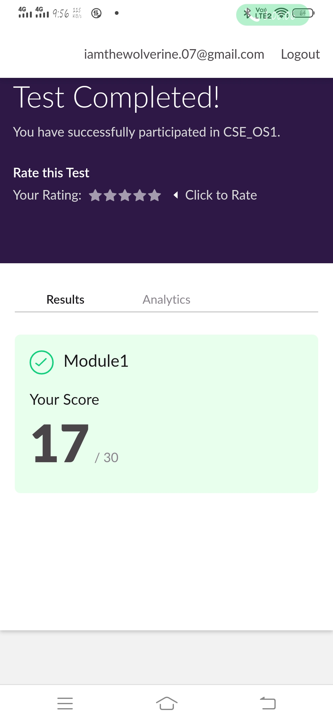

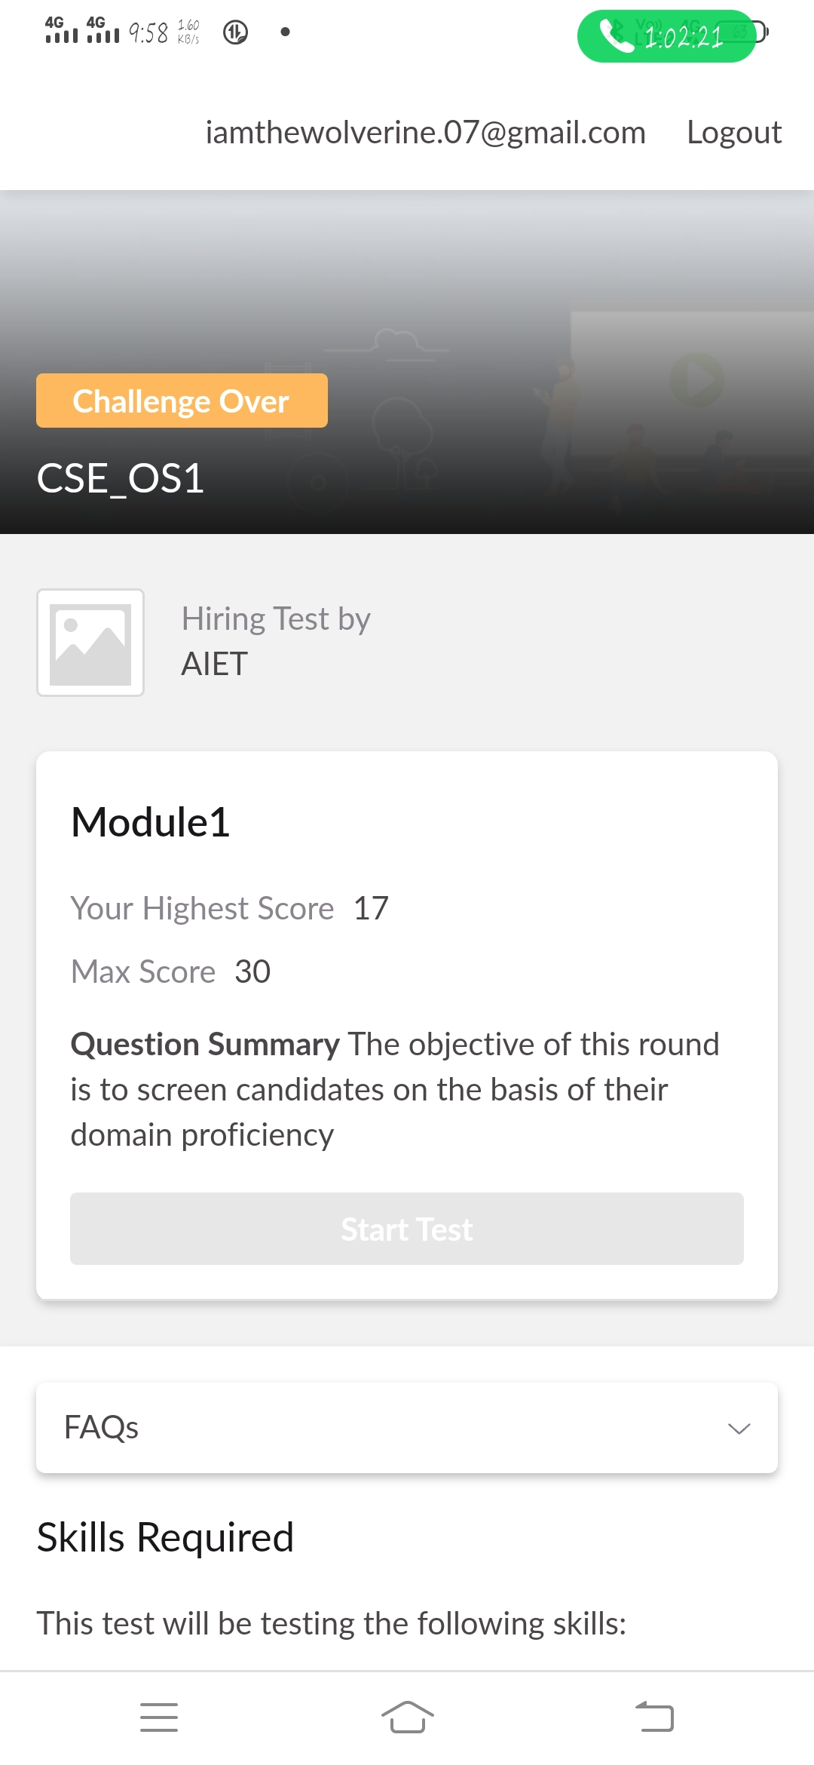

**CERTIFICATION COURSE DETAILS:**

Today i have started new modules of cloud foundation.i.e.,Apps for cloud and security model and Infra.Automation,Abstraction,Provisioning and Allied Tech.

**1.Apps for cloud and security model**

Cloud App Security integrates visibility with your cloud by: Using Cloud Discovery to map and identify your cloud environment and the cloud apps your organization is using. ... Using Conditional Access App Control protection to get real-time visibility and control over access and activities within your cloud apps. While all cloud architecture models require performance management tools and strategy, the security architecture varies based on the type of cloud model — software-as-a-service 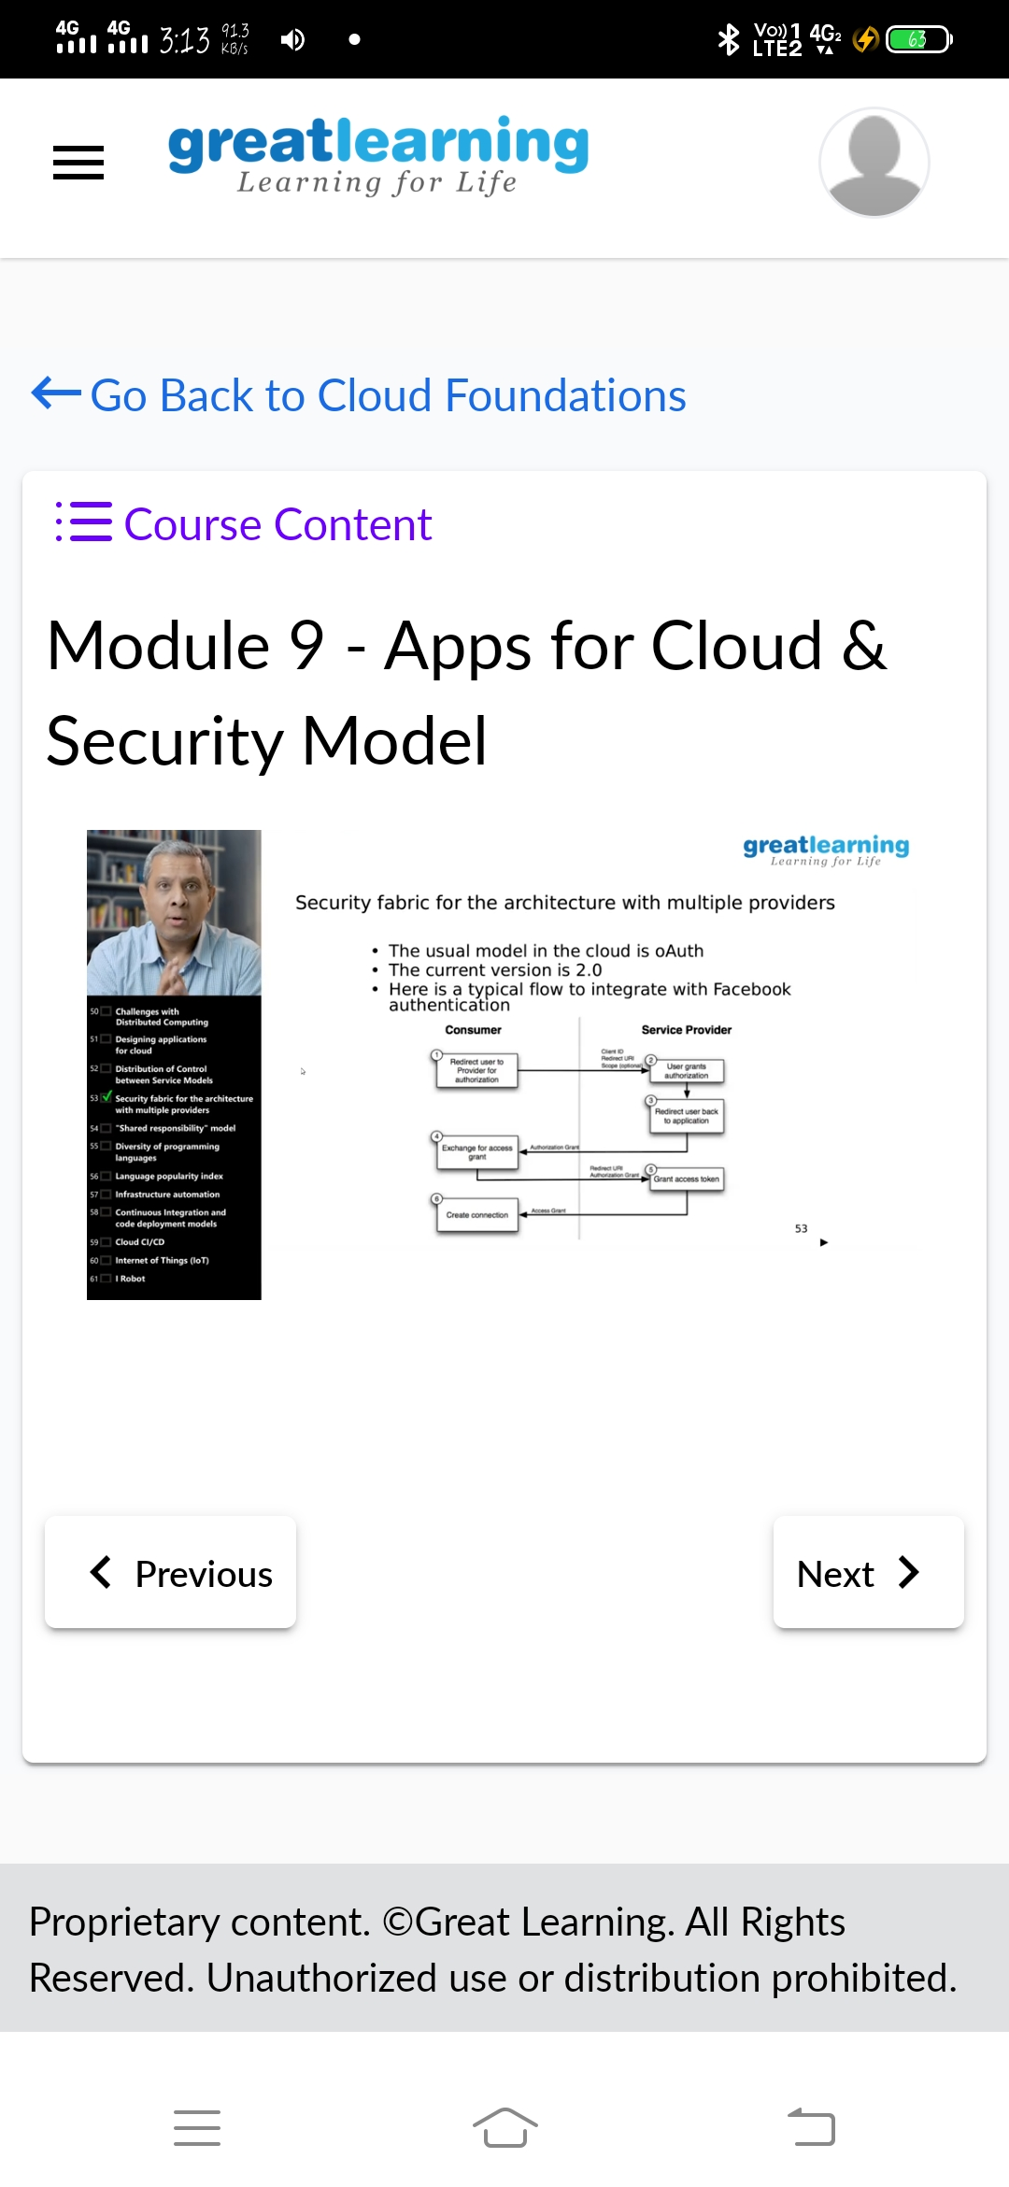(SaaS), infrastructure-as-a-service (IaaS), or platform-as-a-service model (PaaS).

**2.Infra.Automation,Abstraction,Provisioning and Allied Tech.**

Infrastructure automation is the process of scripting environments — from installing an operating system, to installing and configuring servers on instances, to configuring how the instances and software communicate with one another, and much more.Cloud computing with its diverse provisioning models makes it possible for telecom vendors and ... National Institute of Standards and Technology.

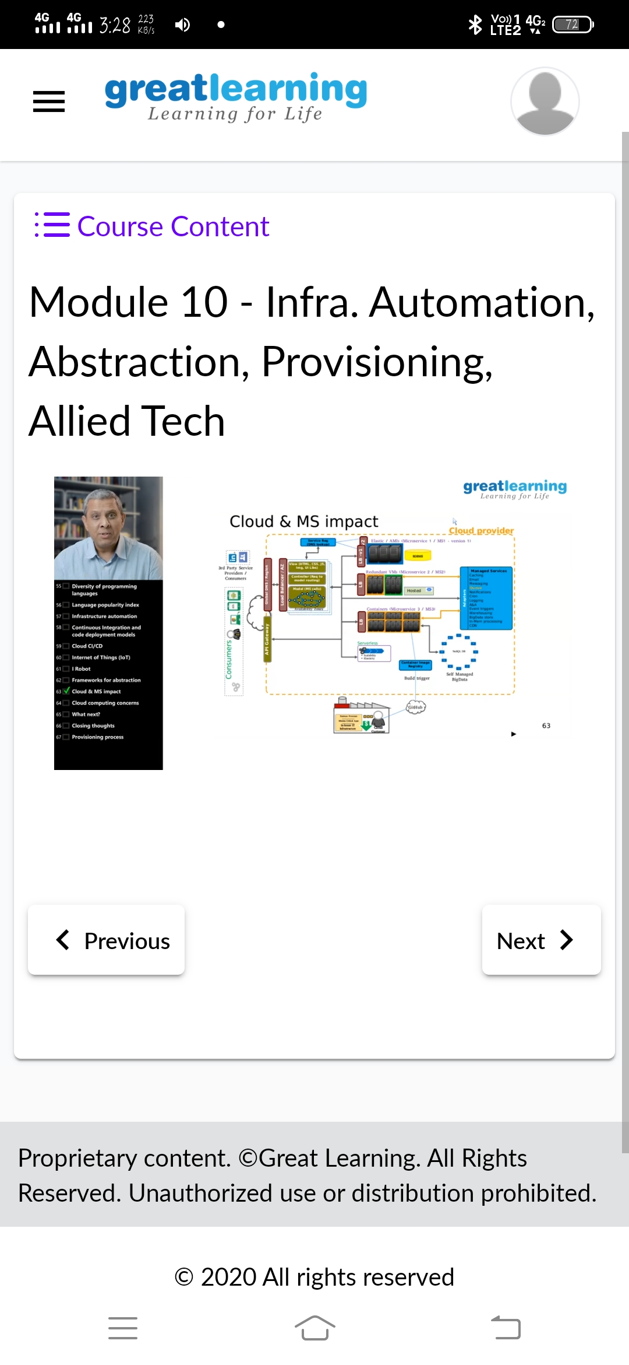

**CODING CHALLENGES DETAILS**:

**Problem statement 1:** Write a C or Java program to implement round robin type of process scheduling.

Input: Process with burst time, arrival time and specify the time quantum

Output: Processes scheduled based on the round robin type of scheduling, with its average waiting time.

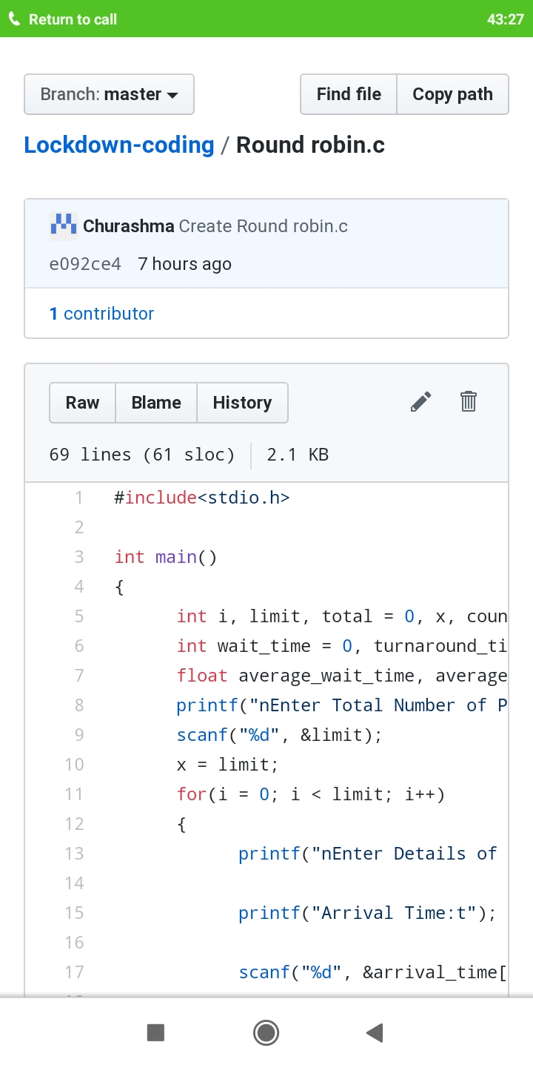

**Problem statement 2 :** Write a C Program to implement various operations on Singly Linked List Stack.

Hint: First Create a Singly Linked List Stack with the node corresponding to First Element is the base of the stack; and its link field must be always Null.

When you push First Element, It is the First and it is Base of the stack. Its Link must be Null. Top pointer pointing to First. (top = First)When you push any element, (No need of checking Stack full case because SLL is dynamic) Create a new node called temp using malloc function and insert the a number into Data field, and Link field must be pointing to top; and move the pointer top to point to temp.When you pop, First check for stack Empty. If First == NULL, then Stack Empty. If it is not empty, The pointer temp must be pointing to top. Move the pointer top to top->link. Delete temp.When you display the stack element, First Check for Stack Empty as in pop operation. If it is not empty, Display all the elements of current stack starting from top to First.

